1. **Create the tar archive from dir2 directory created in previous exercise (Linux exercise 4 - Basic commands) and compress it using gzip.**tar-czf package.tar.gz dir2
2. **Open one of the files you have created earlier with text editor of your choice. Add text to the file and save it with different name.** touch test.txt**,** nano test.tst [text] [exit], cat new_test.txt [shows text edited]*vim File2.txt*  
   Text(edit): *“This file is opened with VIM.  
    yey. huhhhhrah. banzai. kiitos.”*  
   *Esc:w FileInVim.txt* (Enter)  
   *:q!* (Enter)
3. **Open some file using less command. Find out how search feature works in less command.** Less .bashrc*less FileInVim.txt  
   /*(search text)
4. **Download and extract the Apache web server package:**[**Apache web server**](http://student.labranet.jamk.fi/~hantt/apache/httpd-2.4.41.tar.gz)**.**Download: *wget http://student.labranet.jamk.fi/~hantt/apache/httpd-2.4.41.tar.gz*  
   Extract: *tar -xf httpd-2.4.41.tar.gz*
5. **Use Vim editor in this task. Open CHANGES file from extracted Apache web server directory and add this line to the beginning of the file:**
   * **====== This file has been edited in *current_date* ======**
   * **Save the file and print first 18 lines of the file to the command line.** Vim httpd-2.4.41/CHANGES, head -18 httpd-2.4.41/CHANGES*cd httpd-2.4.41  
     vim CHANGES  
     head -18 CHANGES*

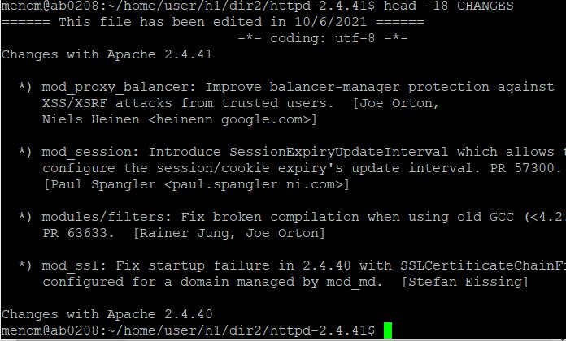

1. **Open Kernel log file (/var/log/kern.log) using tail command so that new log lines are listed in real-time.** Tail -f /var/log/kern.log
2. **Examine curl program parameter through help feature. Download Funet network's wiki page****<https://fi.wikipedia.org/wiki/Funet> and save the content of the page to the file (Write to file) called funetpage.html. Add screenshot presenting part of this file's content.** Curl https://fi.wikipedia.org/wiki/Funet, Curl -o /home/user/funetpage.html https://fi.wikipedia.org/wiki/Funet,   
   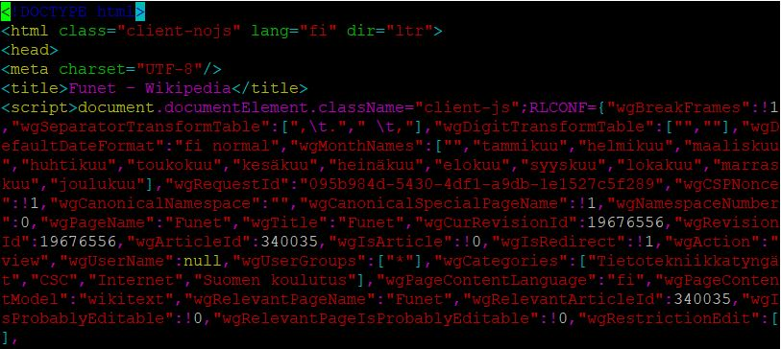
3. **In this task curl command will be used to connect to remote servers:**  
   a) **README file is located in the server http://ftp.funet.fi. How do you open this file using curl command so that you can view it page by page (hint: utilize other commands with curl)?**  
   b) **How do you list the content of remote server's folder ftp://speedtest.tele2.net/? What files are included in listing?**curlftp://speedtest.tele2.net/